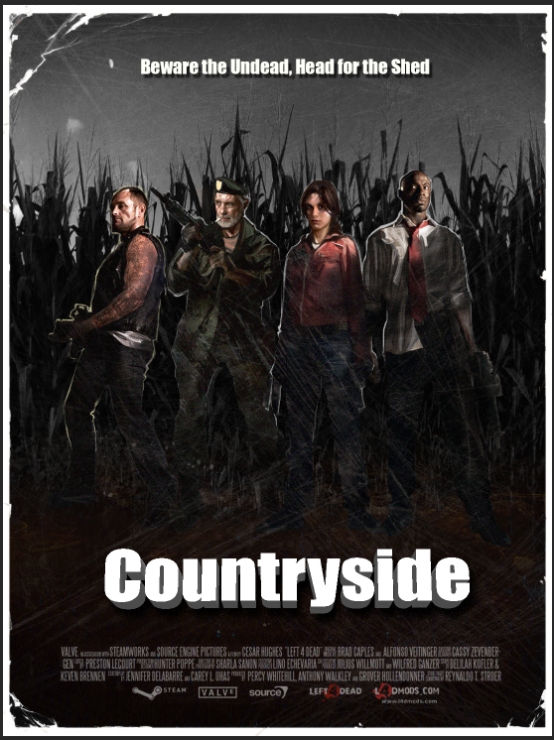

Left 4 Dead 2: Countryside
  - Version 1.0
Designer: | Nicholas Carter
Document Date: | 1/27/20
Intended Level Delivery Date: | 4/28/20

Document Revisions Table
Version | Description | Requestor | Date
1.0 | Initial Document | Professor Stephens | 1/31/20
1.1 | Updated Map & Gameplay Details | Professor Stephens | 2/7/20
1.2 | Updated Figures 1-5 Maps  Updated Table of Figures/Content, Event Descriptions, Quick Summary and Gameplay Hooks | Professor Stephens | 2/14/20
1.3 | Updated Figures 1-6 Maps, Updated Table of Figures, Updated Weapons and Weapon add-ons | Professor Stephens | 3/13/20
1.4 | Updated Figures 1, 2, 4, 5 & 6, Updated Gameplay Highlights | Professor Stephens | 4/3/20
1.5 | Updated Figure 3: Residence Interior & Asset List | Professor Stephens | 4/17/20
1.6 | Updated Table of Contents & Campaign Poster | Professor Stephens | 4/28/20

Table of Contents
Table of Contents 2
Table of Figures 3
Level Information 4
Quick Summary 4
LDD Updates 4
Level Map(s) 5
Countryside Top-Down Overview 5
Shed & Residence 7
The Field 8
Panic Event & Farm 9
Farm Top-Down 11
Objective(s) 12
Hook(s)/Gameplay Highlights 12
Gameplay & Zombie Spawning 12
Development Schedule 12
Key Theme References 13
Shed Safe Room Visual Reference 15
The Residence Visual Reference 16
16
The Residence Interior Visual Reference 17
17
17
The Field Visual Reference 18
The Woods Visual Reference 19
The Farm Visual Reference 20
Countryside Technical Requirements 21
Assets 21
Appendix A: Mission Summary 22
Main Mission 22
References 23

Table of Figures
Figure 1: Countryside Top-Down Overview 6
Figure 2: Shed & Residence 8
Figure 3: The Field 9
Figure 4: Panic Event & Farm 10
Figure 5: Farm Top-Down 11
Figure 4: Contact Sheet for Shed Reference 13
Figure 5: Contact Sheet for Residence Reference 14
Figure 6: Contact Sheet for Residence Interior Reference 15
Figure 7: Contact Sheet for The Field Reference 16
Figure 8: Contact Sheet for The Woods Reference 17
Figure 9: Contact Sheet for The Farm Reference 18

Level Design Document

Level Information

Quick Summary

Countryside is a single level campaign from the multiplayer survival game, Left 4 Dead 2.
The infected swept the Southern States of the US leaving nothing but ruins, abandoned property and many dead victims left on the Countryside’s remains. The survivors recently arrive at the back of the woods as they take refuge inside of the Shed just before Farm home residence before the survivors. Various infected will assault the player as they travel through a homestead, vast open corn fields, The woods and eventually the Neighbor’s Farm where they will breach the ending saferoom! The campaign will take place during dusk as the sun is rising up in the morning and the gameplay is expected to be about 10-11 minutes.

LDD Update

Level Map(s)

Countryside Top-Down Overview
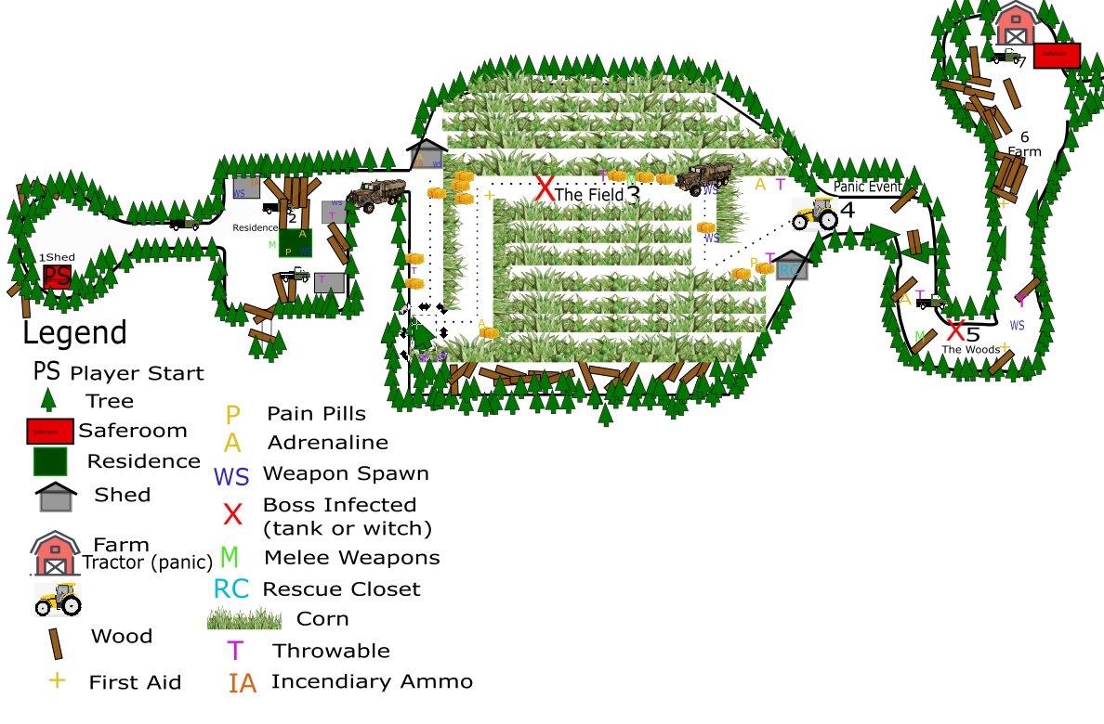

Figure 1: Countryside Top-Down Overview
Map Label | Event Description | Detail Information | Approx. Difficulty (1-10) | Approx. Time | Wow?
1 | Player start Shed | Players will begin the level in a shed just outside of the woods before reaching the Residence ahead. | 0 | 0:00 | N
2 | Players will progress to The Residence. | After leaving the shed and progressing out of the woods, players can explore the residence for necessary resources and materials for survival. The player should have access to SMG’s, shotguns and a small selection of melee weapons. | 3 | 1:25 | N
3 | Advance to The Fields | Once player gather resources, the player will stumble across the fences that eventually guide the player(s) to the vast open fields full of wicked infected. Before reaching the woods, players will have an opportunity to search for resources at the sheds nearby the Woods before they must move the tractor ahead. | 5 | 3:40 | Y
4 | Move the Tractor (Panic Event) | Upon barreling through The Fields full of infected, the players must start and move the tractor from in front of The Woods, alerting the horde for the Gauntlet. | 7 | 5:25 | Y

Shed & Residence
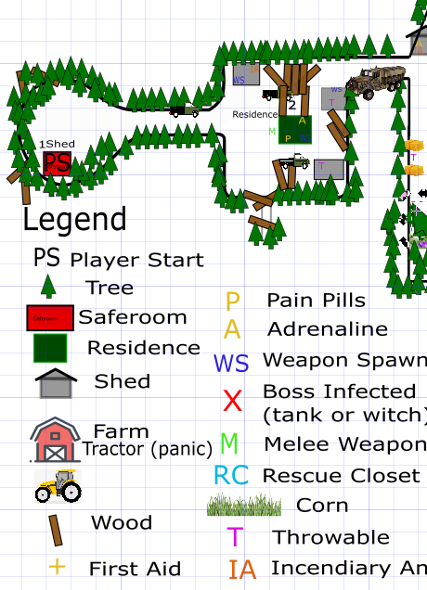

Figure 2: Shed & Residence

Residence Interior

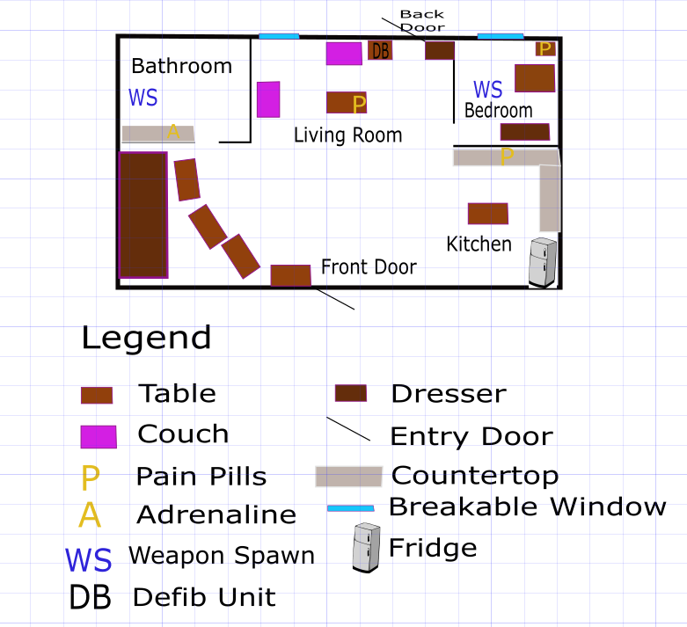

Figure 3: Residence Interior

The Field
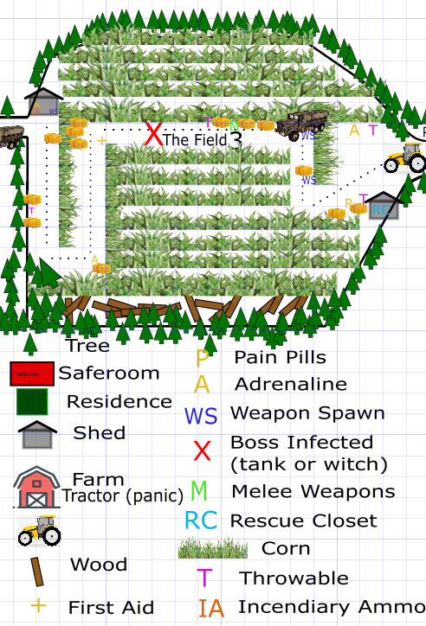

Figure 4: The Field

The Woods
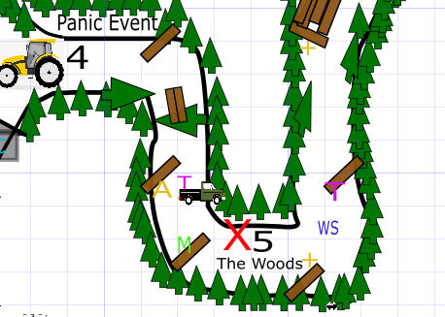

Figure 5: The Woods

The Farm (Saferoom)

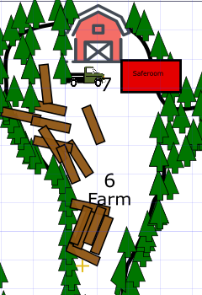

Figure 6: The Farm Saferoom

Map Label | Event Description | Detail Information | Approx. Difficulty (1-10) | Approx. Time | Wow?
5 | Progress through The Woods | Players will rush through wooded area after moving the tractor from in front of the entrance. Zombies will rush the players from all directions as they rush from the Fields and tower from the thick tree lines before reaching the final scene, Farm. | 7.5 | 7:35 | Y
6 | Reach the Farm | The Neighbor’s Farm is the final location the player will need to evacuate the level. En route to the Farm collect resources and health in the wood to help you reach the ending safe room shed just outside The Farm. | 7 | 11:55 | Y

Objective(s)
- Players will use a variety of guns and melee weapons to progress from the Shed to The Neighbor’s Farm on the countryside.
  - Player(s) must cross the field, move the tractor, fight the vicious horde and navigate to the Farm shed to evacuate The Countryside.

Hook(s)/Gameplay Highlights
- Panic Event: At the midpoint of the level, players will encounter a tractor that needs to be started and moved. Moving this tractor will alert a vicious horde that will send the players rushing through The Woods.
- Gauntlet Event: After sparking the horde up from moving the tractor, the infected will continuously spawn until players have successfully reached the saferoom at The Farm.
  - Tips: It’s suggested that players save or use their Adrenaline shots to help them speed through the gruesome Gauntlet
  - Three Distinct Sections:
    - The Shed Residence, The Field & The Woods

Gameplay & Zombie Spawning
- Much of the common infected spawning will be handled by the in-game Director using the nav mesh.
  - Enemies:
    - Common Infected
    - Special Infected: Smokers, Boomers, Hunters, Spitters, Chargers and Jockeys
    - Boss Infected: Witch, Tank
  - Opportunities for spawning a Tank or Witch will be explored using Nav mesh edits in The Field segment of the level.

Heavy Weaponry
  - M60 (located in the field)
  - Chainsaw (located in the field Shed)
  - Grenade Launcher (located in the field near abandoned military vehicle)

Weapon Add-ons
- Incendiary Ammunition (located in the Residence Shed)
- Explosive Ammunition (located in the Field Shed)

Development Schedule
Milestone | Date
LDD | 1/31/20
Whitebox | 2/21/20
Initial Gameplay | 3/13/20
Gameplay Complete | 4/3/20
Aesthetics | 4/17/20
RTM | 4/28/20

Key Theme References

Shed Safe Room Visual Reference
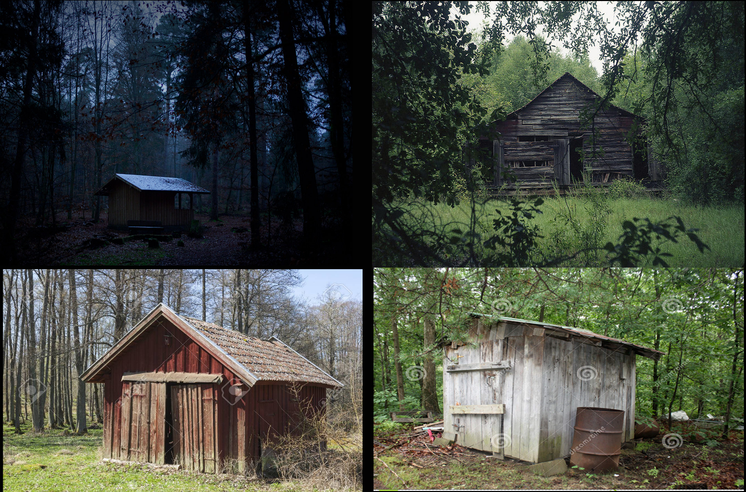
Figure 6: Contact Sheet for Shed Reference

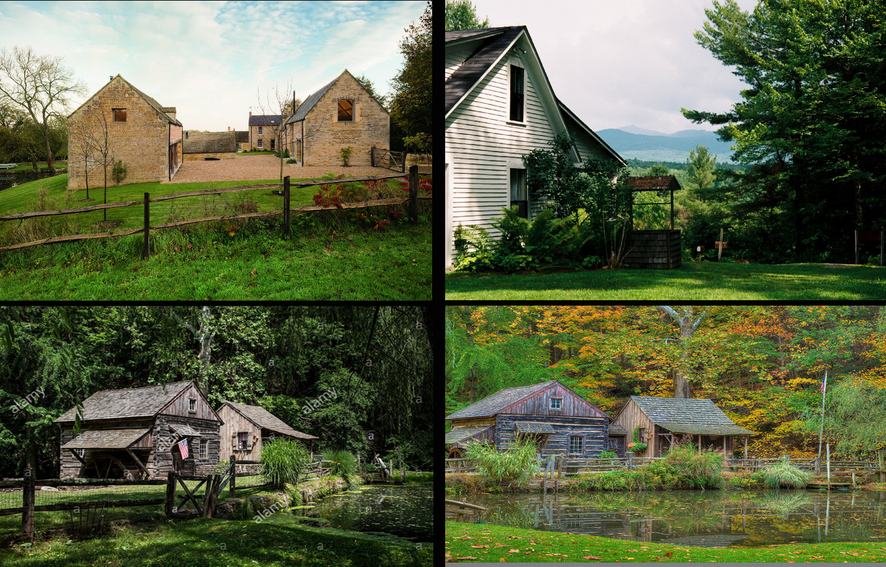
The Residence Visual Reference
Figure 7: Contact Sheet for Residence Visual Reference

The Residence Interior Visual Reference

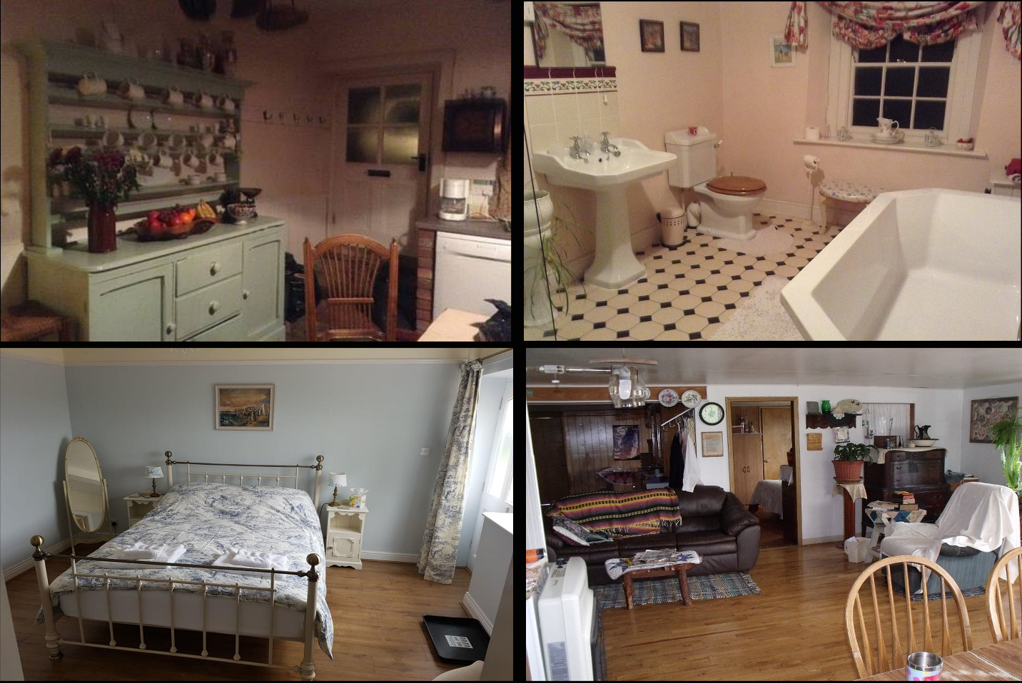
Figure 8: Contact Sheet for Residence Interior Visual Reference

The Field Visual Reference
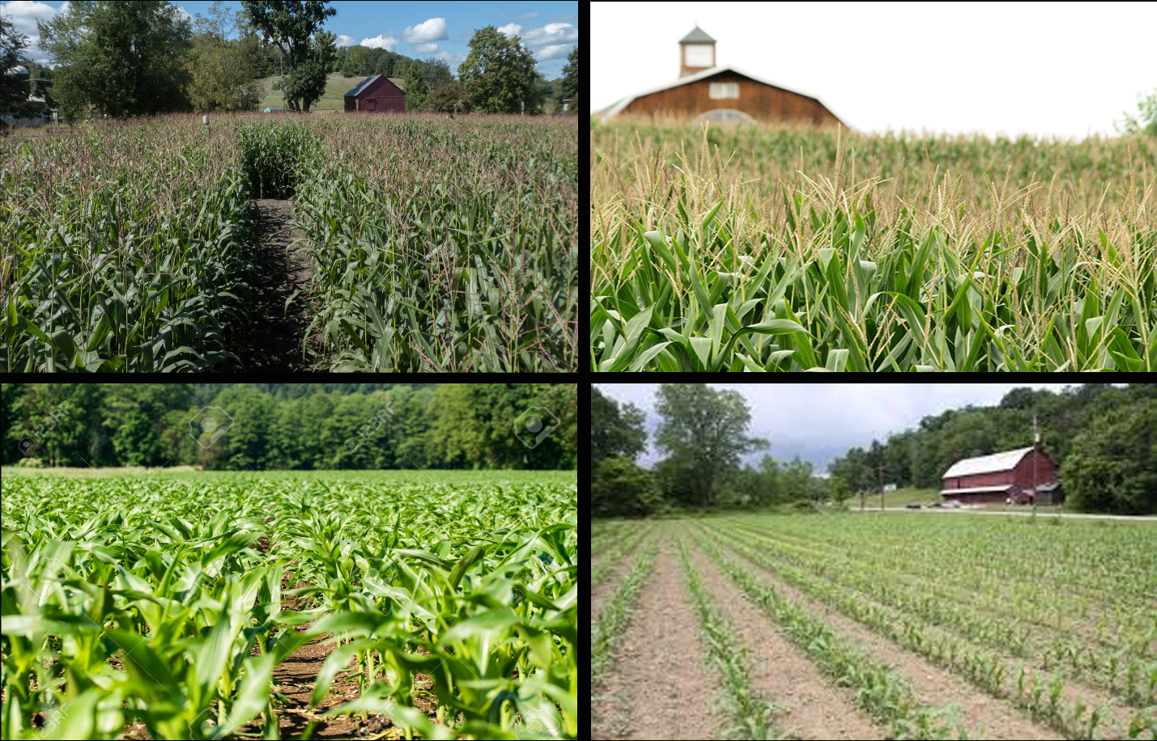

Figure 9: Contact Sheet for The Field Visual Reference

The Woods Visual Reference

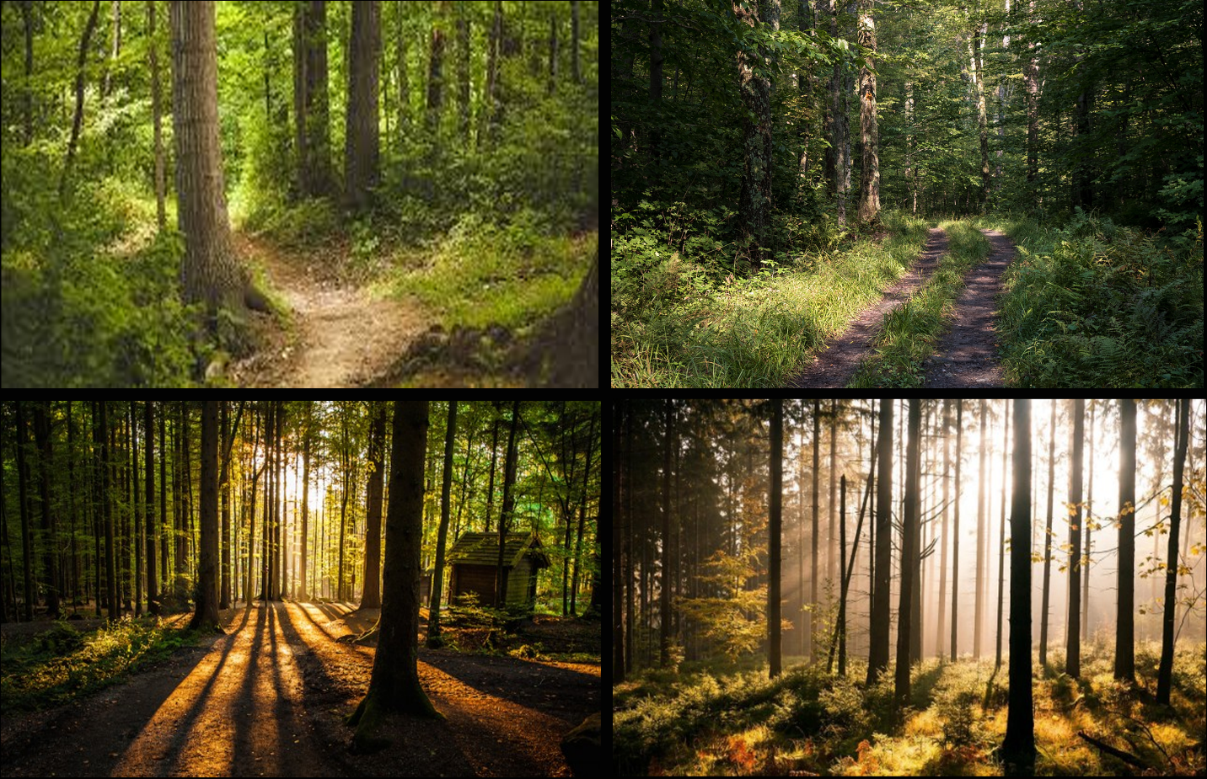

Figure 10: Contact Sheet for The Woods Visual Reference

The Farm Visual Reference
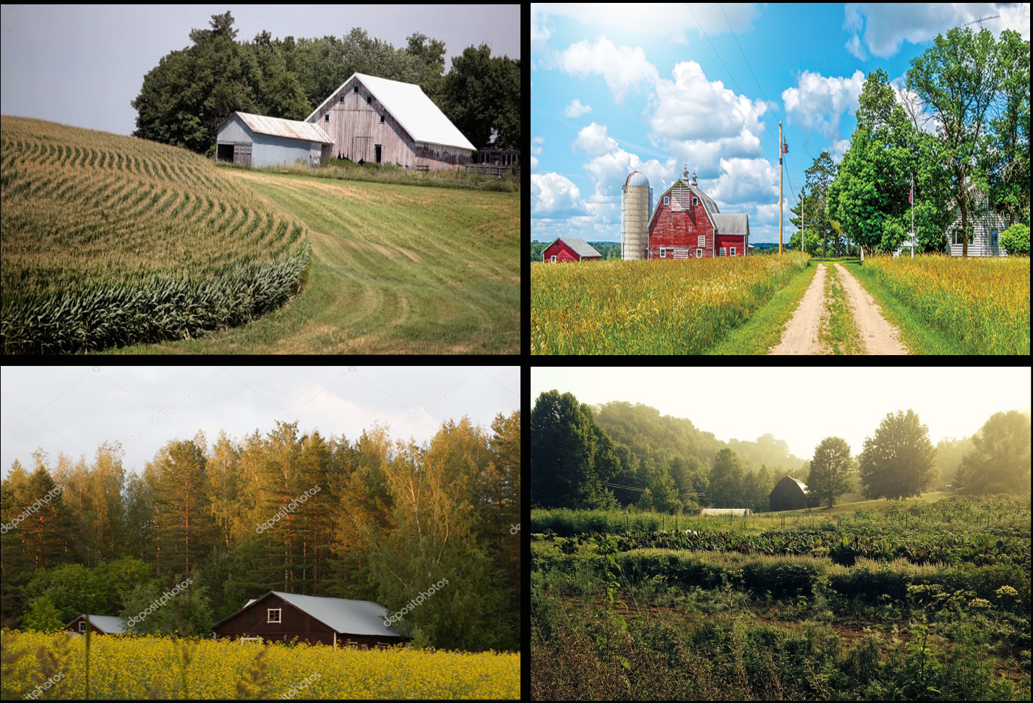

Figure 11: Contact Sheet for Farm Visual Reference

Countryside Technical Requirements
Description | Type | Priority
Level Blockout Construction | Design | High
Nav Mesh Generation + Adjustments | Design | High
Rescue Closets | Design | High
AI Director | Design/Scripting | High
Set Dressing/Aesthetics | Level Art | High
Terrain Patching & Displacement | Design | Low
Panic Event/Crescendo Event | Scripting | High
Campaign End Sequence | Scripting | Medium

Assets
- Large Dense Trees
- Pine Tree (individual + collection)
- Fence
- Foliage
- Haybells
- Wooden Spools
- Wheel Barrows
- Truck
- Tractor (moveable model)
- Dead Zombies
- Windows
  - Decals
    - Trash
    - Blood
    - Leaves
  - Environment Entities
    - Fire
    - Sparks
    - Smokestacks
Interiors will be mostly handcrafted using BSP.

Appendix A: Mission Summary

Main Mission
- Players will begin the level in a shed just outside of the woods before reaching the Residence ahead
- After leaving the shed and progressing out of the woods, players can explore the residence for necessary resources and materials for survival. The player should have access to SMG’s, shotguns and a small selection of melee weapons.
- Once player gather resources, the player will stumble across the fences that eventually guide the player(s) to the vast open fields full of wicked infected.
- Upon barreling through The Fields full of infected, the players must start and move the tractor from in front of The Woods, alerting the horde.
- Players will rush through wooded area after moving the tractor from in front of the entrance. Zombies will rush the players from all directions as they rush from the Fields and tower from the thick tree lines before reaching the final scene, Farm. Navigate through the woods to the Farm to end the level. The player will be able to find and use resources like adrenaline and pain pills along the way.
- The Neighbor’s Farm is the final location the player will need to reach the Ending saferoom to complete the level.

References
[1]
https://www.google.com/search?q=farm+home+countryside&tbm=isch&ved=2ahUKEwiC8aLVl6fnAhUSYawKHdsnA_IQ2-cCegQIABAA&oq=farm+home+countryside&gs_l=img.3..0i8i30.4555.5188..5257...0.0..0.54.221.5......0....1..gws-wiz-img.......35i39j0i5i30j0i8i10i30j0i8i7i30j0i8i7i10i30.2AontqbqXoE&ei=WKAwXoLlB5LCsQXbz4yQDw&bih=625&biw=1280&rlz=1C1CHBF_enUS810US810#imgrc=deezy1zkdxfs3M&imgdii=34oplSjy9CYryM
https://www.google.com/search?q=farm+home+in+the+woods&tbm=isch&ved=2ahUKEwjLzemgoKfnAhVE5KwKHcCRDHMQ2-cCegQIABAA&oq=farm+home+in+the+woods&gs_l=img.3...120407.121192..121332...0.0..0.56.311.7......0....1..gws-wiz-img.......35i39.d9oKyub_liE&ei=WqkwXsu4A8TIswXAo7KYBw&bih=625&biw=1280&rlz=1C1CHBF_enUS810US810#imgrc=R5--KP8laApvmM&imgdii=wJVfrVGJmM5XfM
https://www.google.com/search?q=open+farm+corn+field&tbm=isch&ved=2ahUKEwj5yaCApafnAhVRYKwKHTroA6kQ2-cCegQIABAA&oq=open+farm+corn+field&gs_l=img.3...8549.9615..10148...0.0..0.55.224.5......0....1..gws-wiz-img.......0.uXSB5or7VFQ&ei=U64wXrnUONHAsQW60I_ICg&bih=625&biw=1280&rlz=1C1CHBF_enUS810US810#imgrc=eacUGtv7KeOepM&imgdii=nWs1Ab-ujW-bqM
https://www.google.com/search?q=wooded+countryside+farm+house&tbm=isch&ved=2ahUKEwjhgdXep6rnAhVRja0KHcTTAPUQ2-cCegQIABAA&oq=wooded+countryside+farm+house&gs_l=img.3...5696.8439..8587...1.0..0.88.964.13......0....1..gws-wiz-img.1X7gAQhQGYQ&ei=2kMyXuEs0Zq2BcSng6gP&bih=625&biw=1280&rlz=1C1CHBF_enUS810US810#imgrc=yHR1eHVKNJb90M
https://www.google.com/search?q=the+woods&tbm=isch&ved=2ahUKEwiGsenzr67nAhVPFM0KHTxtAbIQ2-cCegQIABAA&oq=the+woods&gs_l=img.3..0i67j0l9.1285526.1285526..1286017...0.0..0.84.84.1......0....1..gws-wiz-img.wafagPRte8I&ei=SGU0XobtMc-otAa82oWQCw&bih=625&biw=1280&rlz=1C1CHBF_enUS810US810#imgrc=oT9Mzbj9_CyoIM&imgdii=CmZuw1nHMVcNNM
https://www.gites.fr/gites_the-dash-farmhouse_bassenthwaite_h1763017_en.htm

