`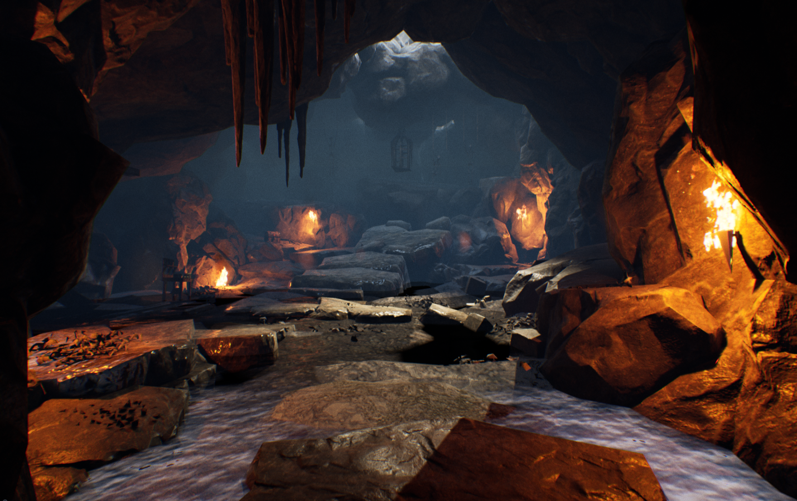

GB Design Test [***Slaughter Cavern***]

Version 1.0

|  |  |
| --- | --- |
| Designer: | Nicholas Carter |
| Document Date: | 2/3/21 |
| Intended Level Delivery Date: | 2/16/21 |

**Document Revisions Table**

|  |  |  |  |
| --- | --- | --- | --- |
| **Version** | **Description** | **Requestor** | **Date** |
| 1.0 | Initial Document | Gearbox Level Design Team | 2/3/21 |
| 1.1 | Final Additions & Alterations | Gearbox Level Design Team | 2/16/21 |

# Table of Contents

Table of Contents 2

Table of Figures 3

Level Information 4

Quick Summary 4

Level Map(s) 5

Slaughter Cavern Top-Down Overview 5

Cavern – Player Start & Corridor 7

Slaughter Cavern Combat Zone 8

Slaughter Cavern (Full No Legend) 9

Objective(s) 10

Hook(s)/Gameplay Highlights 10

Intended Gameplay Highlights 10

Development Schedule 11

Key Theme References 12

Slaughter Cavern Visual Reference 1 12

Cave Visual Reference 2 13

13

Cavern Pillars Visual Reference 3 14

14

14

Cave Visual Reference 4 15

Cavern Aesthetic Visual Reference 5 16

Cavern Aesthetic Visual Reference 6 17

Slaughter Cavern Technical Requirements 18

Assets” 19

Technical Details 19

Potential Problems with Design 21

Technical Issues: 21

Appendix A: Mission Summary 21

Main Mission: Circle of Slaughter 21

Wishlist 21

References 22

# Table of Figures

Figure 1: Slaughter Cave Top-Down Overview 5

Figure 2: Cavern Player Start & Corridor 7

Figure 3: Slaughter Cavern Combat Zone Top-Down 8

Figure 4: Slaughter Cavern (Full Map No-Legend) 9

Figure 5: Contact Sheet for Slaguther Cavern (Lost Cave) 1 12

Figure 6: Contact Sheet for Slaughter Cavern (Caustic Cavern) 2 13

Figure 7: Contact Sheet for Caustic Cavern Pillar Visual Arrangement 3 14

Figure 8: Contact Sheet for The Wave Platform Activation Visual Reference 4 15

Figure 9: Contact Sheet for Cavern Aesthetic Visual Reference 5 16

Figure 10: Contact Sheet for Cavern Aesthetic Visual Reference 6 17

Figure 11: Contact Sheet for Cavern Aesthetic Cave Lighting Visual Reference 7 18

Level Design Document

# Level Information

## Quick Summary

***Slaughter Cavern*** is a original Four player cooperative level intended design for ***Borderlands 3’s*** *Circle of Slaughter* game mode.

**Backstory**

Slaughter Cavern was a dugout cave created not too far from the Lost Cave (i.e *Borderlands 1*) onced powered by the crystals from the Lost Cave. This cave was inhabited by raging psycho’s and ravenous bandits that domesticated vicious creatures, to get in the way of the Vault Hunters. The skaggs became too uncontrollable and eventually overran the cave chasing off enemy bandits or psycho. Corners within the combat zone are where holes in the ground are where Skaggs and Spiderants reside and crawl into the combat zone.

Treasures from the bandits are hidden throughout the cave in varied spaces from elevated rocks to grounded treasures rested beside fallen Bandits.

I intend for the level to feel like a cave… very tight and claustrophobic as you’d expect from a cavernous experience. Inside the wave zone, players have the option to be mobile, run, jump and duck through cover, engage in close combat, platforming, hill defense, or long ranged combat. The level has loops and cycles that the player can take for some fun and strategic moments of gameplay during the 5 rounds of fierce combat that can give the player about 10-12 minutes of intend waved combat. The space alone encompasses about 5minutes of exploration and gameplay.

Torches from bandits and previous cave dwellers have been left behind and placed all throughout the cavern to guide the players attention and keep them along the golden path of progression. Ancient statues are left behind but much debris from poor mining is what caused much of this cavernous ruin to fall apart over time.

This Cave is located just outside of the Arid Badlands of Pandora.

## Level Map(s)

### Slaughter Cavern Top-Down Overview

**8**

**5**

**7**

**6**

**4**

**100**

**9**

**3**

**2**

**1**

Figure : Cave Top-Down Overview

|  |  |  |  |  |  |
| --- | --- | --- | --- | --- | --- |
| Map Label | Event Description | Detail Information | Approx. Difficulty (1-10) | Approx. Time | Wow? |
| 1 | **Player start** | Vault Hunter(s) will begin the level inside the starting area where the player can access the **Ammo** & **Meds** vending machine and other resources need be necessary in between Rounds of waved combat deeper within the caverns. | 0 | 0:00 | Y |
| 2 | **Cavern Corridor + Waterfall** | As the player progresses through the tight cavernous halls the player will pass a waterfall burrowed by rocks that’s responsible for the water in the cave. The player will see burning fires and skeleton bodies to give players a foreshadowing of what vicious savagery lies before. | 3 | 13s | N |
| 3 | **Cavern Combat Entrance** | Vault Hunter(s) will approach a rock archway slightly caved in by stalactites and pillars. This path will also be lit for the player to see the intended path of travel. In the distance the player can see godrays. | 0 | 35s | Y |
| 4 | **Cavern Entrance** | The player(s) will be embraced by a very broad open space in contrast to the tight halls the player previously travelled through. Naturally the player will be pulled to many things, but the intention is to have the player travel counter-clockwise following the line of sight, lighting and torches placed. I plan to include a hero piece trophy in the distance that the player can get near. | 3-8 | 45s | Y |

### A picture containing graphical user interface Description automatically generatedCavern – Player Start & Corridor

Figure : Player Start & Corridor

|  |  |  |  |  |  |
| --- | --- | --- | --- | --- | --- |
| Map Label | Event Description | Detail Information | Approx. Difficulty (1-10) | Approx. Time | Wow? |
| 5 | **Path that leads onto Wave activation platform** | Players approach the platform where the Check-In button will be available for the player to activate upon the players request when they are ready to begin waved combat. | 7.5 | 1:15 | Y |
| 6 | **Pillar Pillage** | Vault Hunter(s) encounter the Pillar pillage zone which encompasses what…. You guessed it a pillage of pillars that the player can jump onto like platforms onto other objects or use for cover. These pillars provide players with the ability to access higher levels or the ability to slam down and smash enemies beneath using players like Amara creating splash zones around her foes. | 8 | 1:45 | N |
| 7 | **Platform(KOH Defense)** | Moze thrives in very open areas where her line of sight isn’t restricted. The Bear suit is meant to be used in this zone in conjunction with the rail gun to mow down her enemies before her. | 8 | 2:20 | N |
| 8 | **Bricks of Savior** | There will be Bricks on the ground level beneath the platform that the player can use for cover or use to jump off to access other desired parts of the level. Fl4K’s beast or pet’s can be used in this area in combo with their ranged gun combat from covered positions while the Beast’s do damage. | 7 | 3:10 | N |
| 9 | **Snipers Mount** | Nicely lit from cave natural lighting, the player can jump upon piles of rocks in the walls of the cave to access higher elevations to shoot enemies from beneath while also sending support Beasts to the field to muck up combat. | 6 | 3:55 | N |
| 10 | **Explosive Barrel End Loop** | Player will then cycle back to the beginning of the cave entrance or proceed to go up the platform panel and resume waved combat. | 7 | 4:45 | N |

### Slaughter Cavern Combat Zone

Figure 3: Slaughter Cavern Combat Zone Top-Down

### Slaughter Cavern (Full No Legend)

Figure 4: Slaughter Cavern Combat Zone Top-Down No legend

## Objective(s)

* Players will use a variety of weapons to progress through five rounds of intense waved combat.A picture containing chart

  Description automatically generated
  + Player(s) must access the Wave Start button to begin the Rounds of combat inside the Slaughter Cavern
  + Player can use varies strategies of combat to defeat waves of enemies inside the cave
  + Specific players will have certain challenges for example “Using Amara to perform 3 ground pound” abilities as a chance to gain more rewards through combat.

Unlit image of Meds + Ammo Dump vends

* + Vault Hunters can explore and come across what would be loot for an intended BL experience for the expected FPS RPG Looter.

## A picture containing floor, indoor, dark, wood Description automatically generatedHook(s)/Gameplay Highlights

* *Borderlands 3* style level, intended designed for *Circle of Slaughter* waved combat gameplay.
* Level supports various strategies of combat like mobile, tactical, zoned combat ranged, close ranged and platforming!

In-game Loot Boxes (not functional)

* *Moze* can defend zones and lockdown areas (more specifically like The Hill)
* *Amara* can smash foes beneath her and blasts enemy directly in her line of sight.
* *FL4K* can use beast with his/her cover to strategies enemy assault or use elevation with ranged weapons.
* Fun moment: players can jump from pillar to pillar to access higher pillars and eventually allow the players to breach other spaces they can use to there advantage in combat.
* Loops within the level where players can run, jump and ground pound with Amara dealing splash damage is what I also intend for combat with the pillars.
  + *As a designer* I wanted to create engaging loops within this level where it be cover or platforms to give players recursive, fun and challenging sequences within the combat

## Intended Gameplay Highlights

* **Four player cooperative gameplay**
* 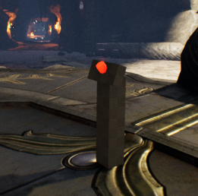Intended Playable Characters: Borderlands 3 *Vault Hunters* 
  + *FL4K: Beastmaster*
  + *Moze: Bear Operator*
  + *Zane: Bomberman Sr.*
  + *Amara: The Aggro Siren*

In-game Proxy Wave Activation Button

* Intended Enemies in waved combat
  + *Wave 1: Skags, Rakks*
  + *Wave 2: Skags, Rakks, Spiderant*
  + *Wave 3: Psycho’s, Skag, Spiderant*
  + *Wave 4: Psycho’s, Skag, Spiderant*
  + *Wave 5: Psycho’s, Bruisers, Skag, Rakks, Spiderant*
* Inaccessible areas will be blocked off with Rocks, Wooded planks or stalactites protruding upward from the ground that the player evidently can not jump onto.

## Development Schedule

|  |  |
| --- | --- |
| Milestone | Date |
| LDD | 2/4/21 |
| Whitebox Blockout ½ | 2/7/21 |
| Lighting Pass | 2/8-11 |
| Aesthetics Pass 1  Aesthetics Pass 2 | 2/11/21 EOD  2/14/21 EOD |
| RTM | 2/15-2/16 |

***Milestone Definitions:***

**LDD:** document done with all level details and map materials needed to begin level production.

**Whitebox Blockout**: Make sure all Rocks actually have collision. Blocking out of the roof will be done with the art assets instead. BSP and Wall Meshes will be used to create the blockout and basic wall and floor shell of the level. All walls will then be blocked using the rock assets given and all ceiling meshes must be added. BSP or placeholder objects can go in game to show path or cover but will be replace in later milestones. First pass lighting will be done, and mich playtesting will be done to see if the space and scale feels as intended before moving on to the next milestone.

**Aesthetics** **Pass1**: All rock assets must be present with no BSP visible. Multiple iterations on lighting and small detail application will be the main focus of this milestone as the priority is to begin to morph the cave space into what you visually interpret from documentation and reference images. SFX and additional lighting will be applied after all things in the environmental have been polished and done.

**RTM:** Take screenshots, package necessary documents and send work to Design Team before EOD (6pm).

## Key Theme References

### Slaughter Cavern Visual Reference 1

Figure 5: Contact Sheet for Slaughter Cavern (inspired by Lost Cave)

### 

### Graphical user interface, diagram, website Description automatically generatedCave Visual Reference 2

### 

Figure 6: Contact Sheet for Slaughter Cavern (inspired by Caustic Cavern)

### Cavern Pillars Visual Reference 3

Figure 6: Contact Sheet for Caustic Cave Pillar Arrangement Visual Reference

## 

### Cave Visual Reference 4

Figure 7: Contact Sheet for (Wave Activation) Visual Reference

### Cavern Aesthetic Visual Reference 5

Figure 8: Contact Sheet for The Cavern Aesthetic Visual Reference

### Cavern Aesthetic Visual Reference 6

Figure 9: Contact Sheet for The Cavern Aesthetic Visual Reference 2

### Cavern Aesthetic Cave Lighting Visual Reference 7

**Figure 10: Contact Sheet for The Cavern Aesthetic Visual Reference 2**

## Slaughter Cavern Technical Requirements

|  |  |  |
| --- | --- | --- |
| Description | Type | Priority |
| Terrain Editing Framework | Design | High |
| Level Blockout Construction | Design | High |
| Placeholder Asset Placement | Design | High |
| Lighting Pass | Level Art | High |
| Aesthetic Pass | Design/Level Art | High |
| SFX Editing & Alteration | Audio/Scripting | Medium |
| FPS Character Jump Height Adjustment | Scripting/Design | High (need to playtest) |

## Assets

Combined assets from the *Soul Cave,* *Infitiny Blade Firelands* & S*tarter Content* Asset packs*.*

*Soul: Cave* is a collection of high-quality rock and water props, materials and textures optimized for mobile platforms. It is one of two free environment asset packs containing content built for the 2014 Soul demo from Epic Games to demonstrate high-end engine capabilities on mobile devices. Download Soul: City and Soul: Cave to gain access to over 1,000 free assets and use them in your Unreal Engine projects today.

### Technical Details

Texture Sizes:

* 256
* 512
* 1024
* 2048

Collision: Yes

LODs: No

Number of Meshes: 173

Number of Materials and Material Instances: 167

Number of Textures: 171

Lava abounds in ***Infinity Blade: Fire Lands***, the radiant castle interior laced with unforgiving paths and dramatic props. It’s one of three environments that ship with the Infinity Blade Collection, a massive suite of content designed for high-quality mobile experiences, released to the Unreal Engine community for free! More than 7,600 assets are included in eight packs filled with characters, weapons, props, sounds, visual effects, and environments to use as you like in your Unreal Engine 4 projects.

CONTENT TERMS FAQ

Q: Can I use the Infinity Blade Collection content in other engines?

A: This content is not permitted for use in non-Unreal Engine games.

Q: What's up with that?

A: In the Marketplace Agreement, Epic is permitted to sublicense the Marketplace content pursuant to the Unreal Engine EULA. In the EULA, a Product is a product that is made using UE4 or that combines the Licensed Technology with any other software or content, regardless of how much or little of the Licensed Technology is used. Licensed Technology is defined to include Content, and Content includes Marketplace Content.

Q: In layman's terms, please...

A: In other words, using Marketplace Content makes a product a Product. These assets can only be used in Unreal Engine 4 projects, with no exceptions.

Licensed for use with the Unreal Engine only. Without a custom license you cannot use to create sequels, remasters, or otherwise emulate the original game or use the original game’s trademarks, character names, or other IP to advertise or name your game.

### Technical Details

NOTE: Screenshots were taken on a desktop PC.  
  
Static Meshes: 407  
Textures: 253  
Materials: 113

**Assets Intended Use:**

* Wood Planks for blocking inaccessible areas
* Debris rock piles for blocking inaccessible areas
* Pillars as platforms
* Stone bricks used for cover or used to access higher levels
* Protruding rocks used for cover
* Metal material used for torches
* Fire burning used for lighting from Starter Content
* Using skeletons and forged weaponry abundantly to set dress level

# 

# Potential Problems with Design

## Technical Issues:

* Not able to truly test out level combat with no Borderland’s like systems available
* Vault Hunter’s like Moze being able to successfully travel through areas of the area without getting stuck on collisions etc
* Performance concerns due to VFX or mesh abundance
* Enemies spawning into level not playtestable
* Enemy Nav mesh issues from collisions
* Too cramped of a space; theme may be doubled-down a bit too much
* Natural Light vs. Fire - Cave light Balance
* Made the beginning of the level a curve to support LOD’s if necessary

# Appendix A: Mission Summary

## Main Mission: Circle of Slaughter

1. Players will begin the level in the CAVERN
2. Vault Hunter(s) will access the vault button
   1. In addition to completing the Circle of Slaughter, Vault Hunter(s) will be tasked with a set of challenges per usual during CoS gameplay expectations.
3. Opportunities for Loot
   1. As the player fights during combat I also wanted to provide the opportunity for the Vault Hunters to access other parts of the level with treasure chest that would resemble loot in a Borderland’s experience.

## Wishlist

1. Combining the Soul Cave and City Assets together to create more of a futuristic abandoned cavern
   1. [Soul: City in Epic Content - UE Marketplace (unrealengine.com)](https://www.unrealengine.com/marketplace/en-US/product/soul-city)

## Digital Sources

**Digital Maps Created Using***: Inkscape*

## Background Music: <https://www.youtube.com/watch?v=bthbiJyCClc>

## Waterfall SFX: <https://www.youtube.com/watch?v=bthbiJyCClc>

## Fire_Sparks01_Cue used from Starter Content Sound Cue

# References

* [Soul: Cave in Epic Content - UE Marketplace (unrealengine.com)](https://www.unrealengine.com/marketplace/en-US/product/soul-cave)
* [Infinity Blade: Fire Lands in Epic Content - UE Marketplace (unrealengine.com)](https://www.unrealengine.com/marketplace/en-US/product/infinity-blade-fire-lands)
* <https://borderlands.fandom.com/wiki/Lost_Cave#:~:text=Lost%20Cave%20is%20a%20subterranean,a%20mission%20to%20save%20him>.
* <https://borderlands.fandom.com/wiki/Caustic_Caverns>
* <https://borderlands.fandom.com/wiki/The_Arid_Badlands>
* <https://www.google.com/search?q=dark+cavern+refernce+images&tbm=isch&ved=2ahUKEwj6x9_riNDuAhXSoK0KHQ9fCSoQ2-cCegQIABAA&oq=dark+cavern+refernce+images&gs_lcp=CgNpbWcQA1DICVjGFGDiFWgAcAB4AIABeYgBwgSSAQM2LjGYAQCgAQGqAQtnd3Mtd2l6LWltZ8ABAQ&sclient=img&ei=z9IbYLqkI9LBtgWPvqXQAg&bih=579&biw=1277&rlz=1C1CHBF_enUS810US810#imgrc=2_jdfP8TqH1Q6M&imgdii=VSwk4mmoBFYdMM>
* <https://www.google.com/search?q=dark+cavern+refernce+images&tbm=isch&ved=2ahUKEwj6x9_riNDuAhXSoK0KHQ9fCSoQ2-cCegQIABAA&oq=dark+cavern+refernce+images&gs_lcp=CgNpbWcQA1DICVjGFGDiFWgAcAB4AIABeYgBwgSSAQM2LjGYAQCgAQGqAQtnd3Mtd2l6LWltZ8ABAQ&sclient=img&ei=z9IbYLqkI9LBtgWPvqXQAg&bih=579&biw=1277&rlz=1C1CHBF_enUS810US810#imgrc=2_jdfP8TqH1Q6M>
* <https://www.google.com/search?q=cave+campfire&rlz=1C1CHBF_enUS810US810&sxsrf=ALeKk03WWhZp83JcUe2lD-vDPB9zdaAWbQ:1613502529241&tbm=isch&source=iu&ictx=1&fir=z2qu7gubF8R82M%252CEomg1QUWLxeZXM%252C_&vet=1&usg=AI4_-kQ32YUSo4TN1KdG182X3OQAPD3QXA&sa=X&ved=2ahUKEwi7wuWoje_uAhUEVs0KHb6nBRQQ9QF6BAgNEAE#imgrc=z2qu7gubF8R82M>
* <https://www.youtube.com/watch?v=bthbiJyCClc>
* <file:///C:/Users/Nicholas%20Carter/Downloads/Level%20Design%20Test.pdf>